Kodu Curriculum: Getting Started
with Keyboard and Mouse

PC Requirements
- Kodu requires a Windows Operating System
- DirectX9 graphics
- Shader Model 2.0 or greater.

How to Check Your DirectX Version
- For Windows 7 or Vista: In Start Menu type into the search box the letters Cmd For Windows XP: In Start Menu select Run and then type Cmd (on Windows XP).
- Next, in prompt type Dxdiag. The first tab will list your DirectX Version.
If you do not have .NET Framework v3.5 and XNA Game Studio v3.1, the installer will prompt you to install these.
Download Kodu from http://fuse.microsoft.com/kodu

Optimizing Kodu to Run on Your PC
If the game is displaying smoothly, your frame rate is acceptable. (For a good gaming experience, you will need a frame rate of at least 20 frames per second.)
If Kodu is jerky when you try to use it, there are some steps to improve the experience.

How to View the Frames per Second
Select “Configure Kodu Game Lab” from the PC’s programs menu, this will open the Configuration Tool Panel. Check “Frames per Second”
The next time the Game Lab is started, the Frames per Second (fps) will be displayed. This display can also be turned off by un-checking “Frames per Second” in the configuration tool panel at any time.

How to Increase the Frame Rate
- Change from Shader Model 3 (if selected) to Shader Model 2 in configuration tool panel
- Deselect Fullscreen
- Use the dropdown box in the configuration tool to reduce your screen resolution – this will decrease the detail of the image, thereby using less processing power.
- Uncheck the 3 graphical options (glow, anti-aliasing and animation)
NOTE ABOUT LAPTOPS: On certain laptops with integrated graphics, Kodu may not perform optimally, but you can still get a sense of the tools and flow of the game.

Entering the Program
- Kodu can be found under the Microsoft Research grouping on your Program menu.

- Once in Kodu, you should choose the “Load World”  Once here you can either view existing games or start a new game. | 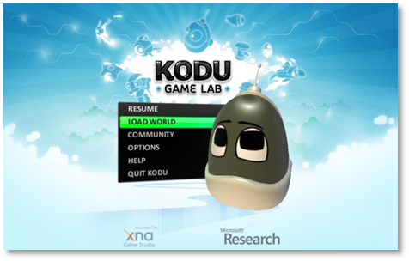

For more detailed information on navigation:

http://community.research.microsoft.com/blogs/kodu/archive/2010/01/15/tutorial-1-basic-navigation.aspx

Exploring the Worlds
- After choosing “Load World”, you can select an Existing World (game)or an “Empty World” to start a new world.  We recommend first exploring the existing games. (Some are full games, others are worlds that have been designed but may not have game play.) By default they are sorted by date. Filters and sorts can be set at the top. | 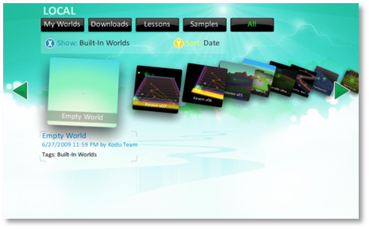
- By default you can see all worlds. Some  are titled as “Tutorials” to help you get started; others are titled “Technique” to demonstrate specific procedures.  The tutorials are highly recommended at this point. To locate the first tutorial. Use your arrow key and scroll towards the end. The first tutorial is titled Tutorial 01 v03 | 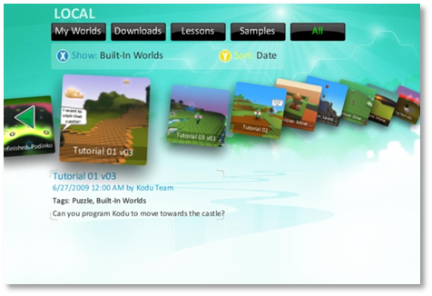
Not All Worlds Support Mouse and Keyboard  Currently, not all games support both mouse and keyboard and Xbox controller play.  When you save a game, you can associate a tag with it, and on the Load Level menu you can search for worlds tagged with either keyboard/mouse or controller. | 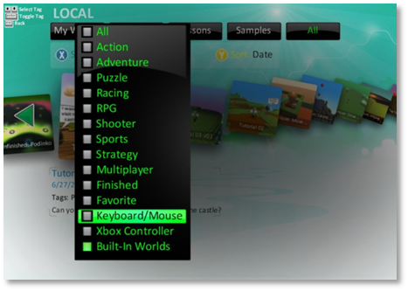
All Worlds Start in Play Mode  When you load a world, it starts in the play mode, though it may first have instructions to inform you of how different games work. | 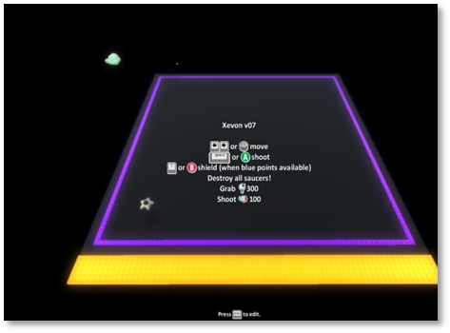

For more detailed information on the Load Level Menu:

http://community.research.microsoft.com/blogs/kodu/archive/2010/01/29/tutorial-3-load-level-menu.aspx

Viewing the Code
- To see how the world was constructed, click escape to edit.  You will then see a strip of editing tools at the bottom. | 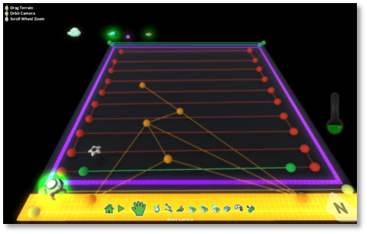
- The Kodu icon lets you add a new character or object by clicking in a space without an object, or edit an existing object, by moving the puck to a space where an object is.  There are 20 types of characters, each with different properties. | 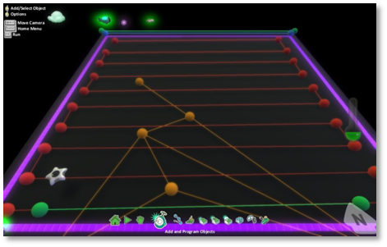
- To view the code, move the puck to an object or character.  The object will glow, and you then right click to see the code. | 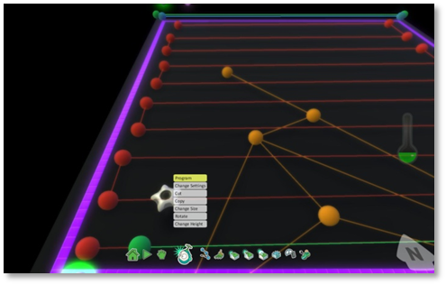

For more information on the Edit Menu tools: http://community.research.microsoft.com/blogs/kodu/archive/2010/01/21/tutorial-2-edit-tools.aspx

Creating a New World – Terrain and Characters
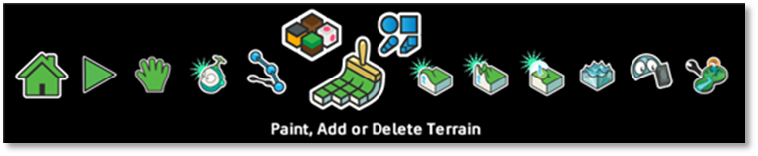
To create a new world, you must first have terrain.
Terrain is created by painting with the terrain tools. You can select a color and a brush type (square, oval, square line, oval line).
One easy way to make terrain is to increase the brush size (using the right arrow) and just put down a single square
- The other tools for dealing with terrain let you raise and lower the terrain, and smooth or make jagged the elevations
- Any water that is added, must have terrain or land under it. By default, each world starts with “glass walls”, so water stays contained and nothing can fall off the edges.
- After you have created terrain, you can add and program objects and characters as described above

For details on the different characters that are available:
http://planetkodu.com/tutorials/view/Introducing_the_Bots

Coding in Kodu
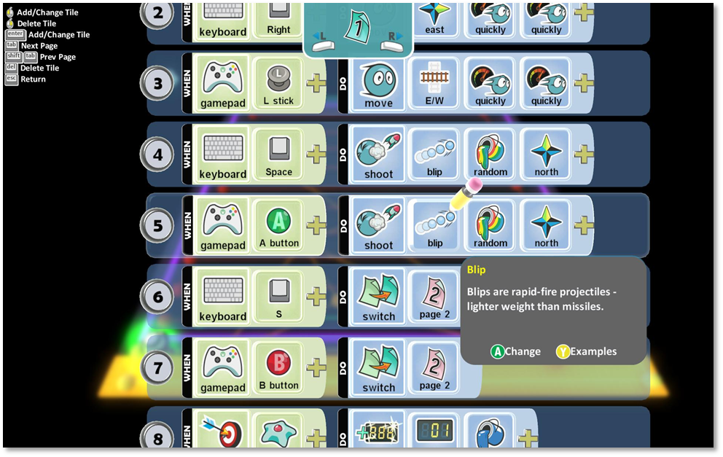

- All Kodu code statements start with a When condition, followed by a Do condition to be executed. The choice of tiles at any point is determined by what went before. Conditions are evaluated simultaneously. If there are no tiles in the When area, then the action will be done at all times.
- The “switch to page x” construct is used for code to be run only after a specific event or condition has been achieved – it is used to create multiple states for a character or object.
- Tiles have help demonstrating how they can be used. (Shown above – press F1 to see the help.)
- Each help screen also provides examples of how to use that particular tile. The example code can be inserted directly by clicking on the image of the A button. You can scroll through examples by clicking on the L in a circle on the left:
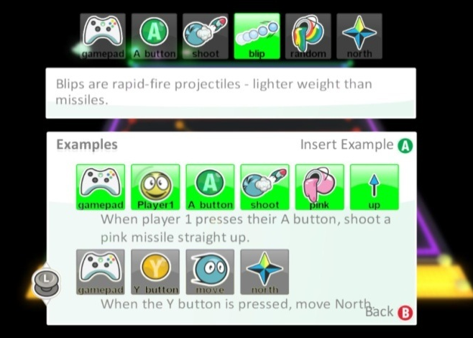

Trying Out Code
When you are done coding, or want to try out the code you have just written, press the escape key to return to the tools menu, then the escape key again to run the game.
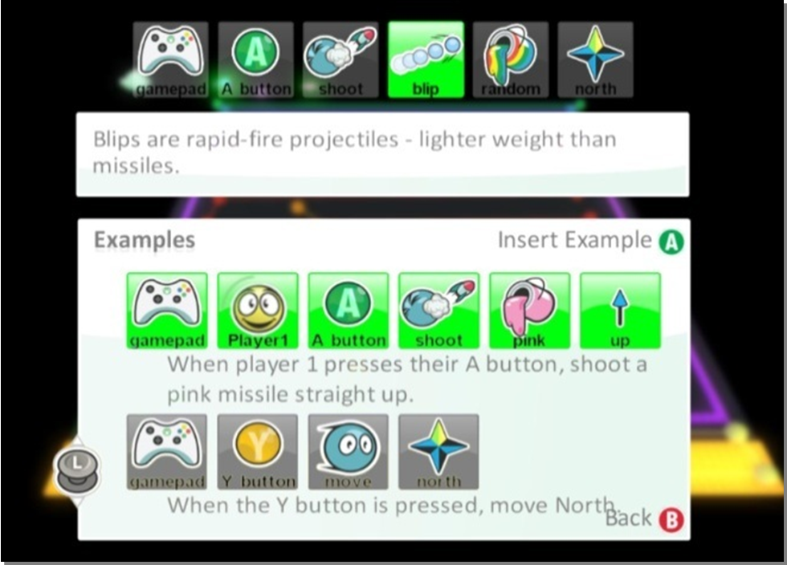
Trying Out Code
- When you are done coding, or want to try out the code you have just written, press the escape key to return to the tools menu, then the escape key again to run the game.

