What is Kodu?
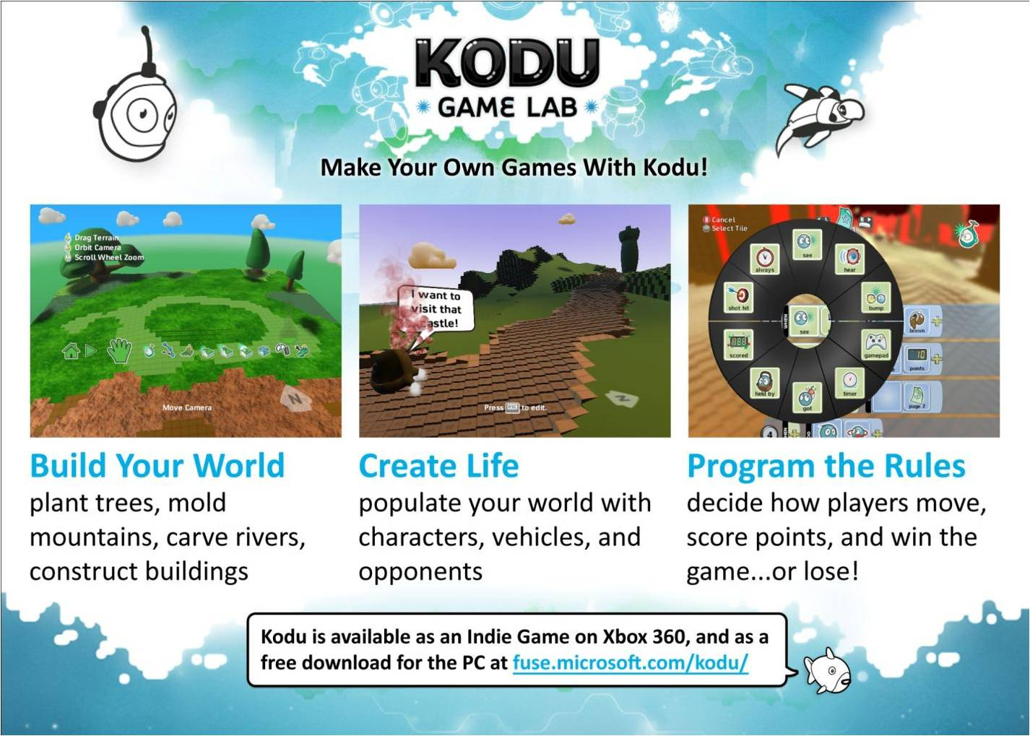
- Kodu is a visual programming language made specifically for creating games. It is designed to be accessible for children and enjoyable for everyone

- Kodu provides easy tools to create elaborate 3D landscapes, and control the lighting and camera
- Kodu programming involves selecting visual tiles for a condition (WHEN) and an action (DO)
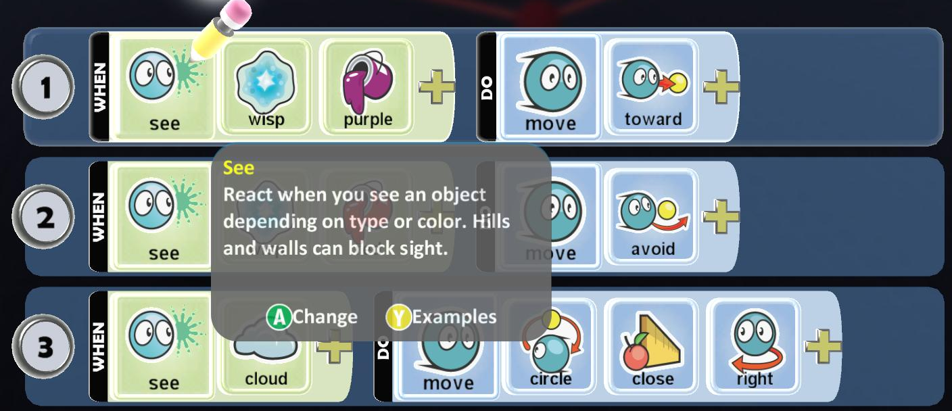
Students can learn about cooperation, logic and creativity, not just about programming
- Kodu is a rich tool for narrative creation and storytelling – pulling users into creating stories
- Kodu demonstrates that programming is a creative medium

What Can Kodu Teach?
- Kodu introduces the logic and problem solving of programming without complex syntax
  - Kodu introduces conditions and sequence, and is object-oriented
- Kodu builds real world, 21st century skills by challenging users to analyze a problem deeply and structure their solution – an approach applicable to all academic subjects, business and personal relationships

Who Can Use Kodu?
- Anyone!
  - It can be taught by any teacher, no previous programming expertise required
  - Ages 8 and up typically have the most success

How Do I Get Started?
Download Kodu for free from fuse.microsoft.com/kodu
You can start by playing the games that come with Kodu – Xevon 07 is one of our favorites. You can either use your mouse and keyboard or an Xbox Controller to play Kodu.
For background and context, check out the postings on our blog: http://community.research.microsoft.com/blogs/kodu/default.aspx

How do I view the Code?
To view code, press the escape button on the keyboard or the back button on the controller to enter edit mode. Then choose the kodu tool from the toolbar at the bottom, move to an object in the world, and right click (mouse) or press the Y button (controller). To practice coding, go to Tutorial 01 and select the Kodu character who wants to get to the castle.

How Do I Create A New Game?
When you’re ready to build your own game, a great starter tutorial is at: http://www.stuartridout.com/post/365351273/this-is-my-first-tutorial-using-kodu-demonstrating
How Can I Share A Game?
From the Load World menu (where you see all the games), select on your game. A menu will pop out to the right with a choice of Play, Export or Delete. Choose Export. The game will be saved to My Documents/SavedGames/Boku/Player1/Export … it’s a small file and can easily be emailed. You can also share it with others at www.planetkodu.com

